MATHEMATICS METHODS

MAWA Semester 2 (Units 3 and 4)
Examination 2017

Calculator-Assumed

Marking Key

© MAWA, 2017
Licence Agreement
This examination is Copyright but may be freely used within the school that purchases this licence.
- The items that are contained in this examination are to be used solely in the school for which they are purchased.
- They are not to be shared in any manner with a school which has not purchased their own licence.
- The items and the solutions/marking keys are to be kept confidentially and not copied or made available to anyone who is not a teacher at the school. Teachers may give feedback to students in the form of showing them how the work is marked but students are not to retain a copy of the paper or marking guide until the agreed release date stipulated in the purchasing agreement/licence.

The release date for this exam and marking scheme is
the end of week 1 of term 4, 2017

Section Two: Calculator-assumed (99 Marks)

Question 10(a)
Solution
Isotope A decays faster.
Reason: Its half-life is less than the half-life of isotope B, i.e. it loses half of its mass faster than isotope B loses half of its mass.
Marking key/mathematical behaviours | Marks
- answers correctly  - uses the concept of half-life correctly | 1  1

Question 10(b)
Solution
May assume that 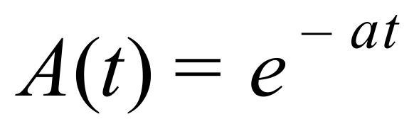 and 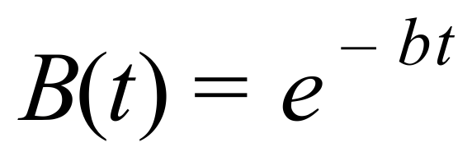 where 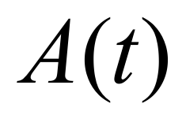 and 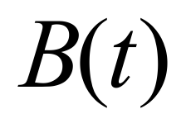 are the amounts of isotopes A and B respectively,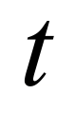 years from now.
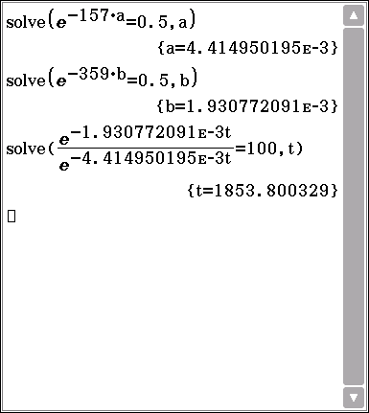
Using the half-lives: 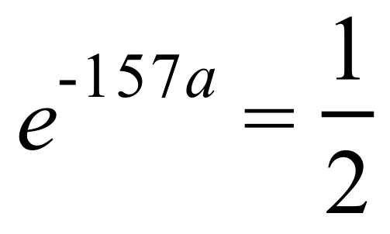 and 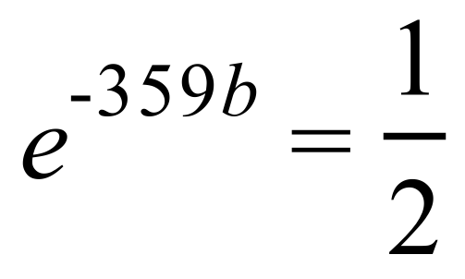.
So 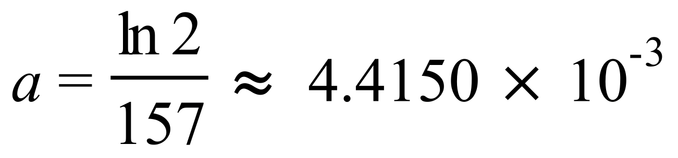 and 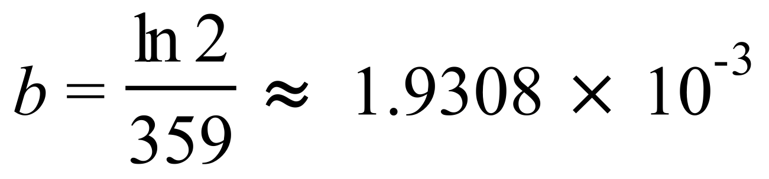
When 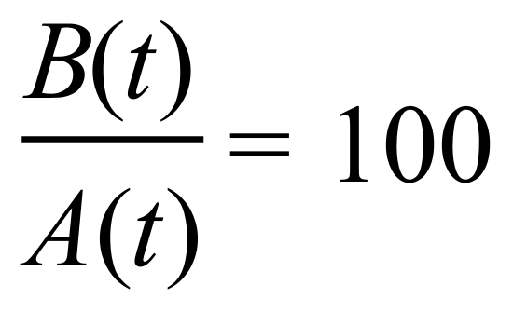, 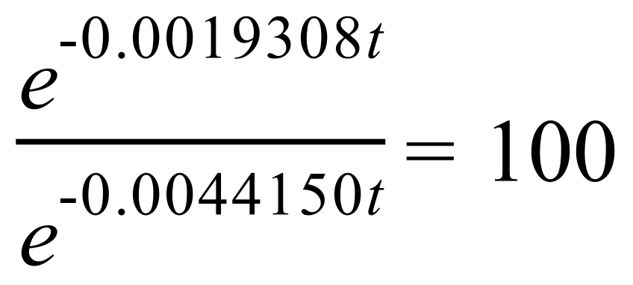 (#)
i.e. 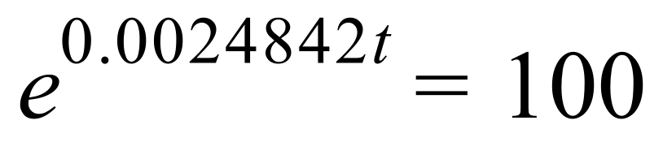 , i.e. 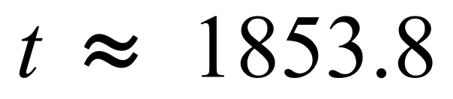
So it takes 1854 years before the ratio of the concentrations become 100 to 1.
Marking key/mathematical behaviours | Marks
- uses exponential models for the amounts of isotopes at time   - uses half-lives to solve for the constants 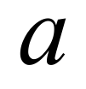 and 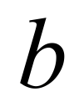 correctly  - uses equation (#)  - solves for the time, correct to the nearest year. | 1  1  1  1

Question 11(a)
Solution
Population would be all the people eligible to vote in the election
Sample is the 100 voters asked

Marking key/mathematical behaviours | Marks
- Identifies population correctly  - Identifies sample correctly | 1  1

Question 11(b)
Solution
Use a method to randomly choose 100 people from the electoral role

Marking key/mathematical behaviours | Marks
- states a suitable method | 1

Question 11(c)
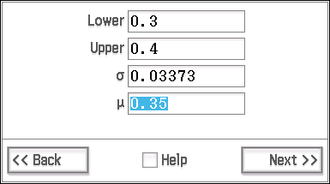
Solution
For 100 estimate of proportion is 0.35

For 200 $E\left(\hat{p}\right)=0.35$

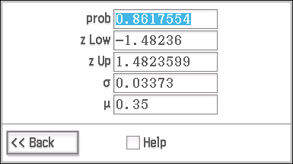
Std Dev $(\hat{p})$ = $\sqrt{\frac{0.35(1-0.35)}{200}}$

= 0.03373

$\hat{p } \sim N(0.35. {0.03373}^{2})$

$P\left(0.3< \hat{p}<0.4\right)=$0.8618
Marking key/mathematical behaviours | Marks
- evaluates the standard deviation accurately  - states distribution of $\hat{p}$ correctly  - Evaluates correct probability | 1  1  1

Question 12(a)
Solution
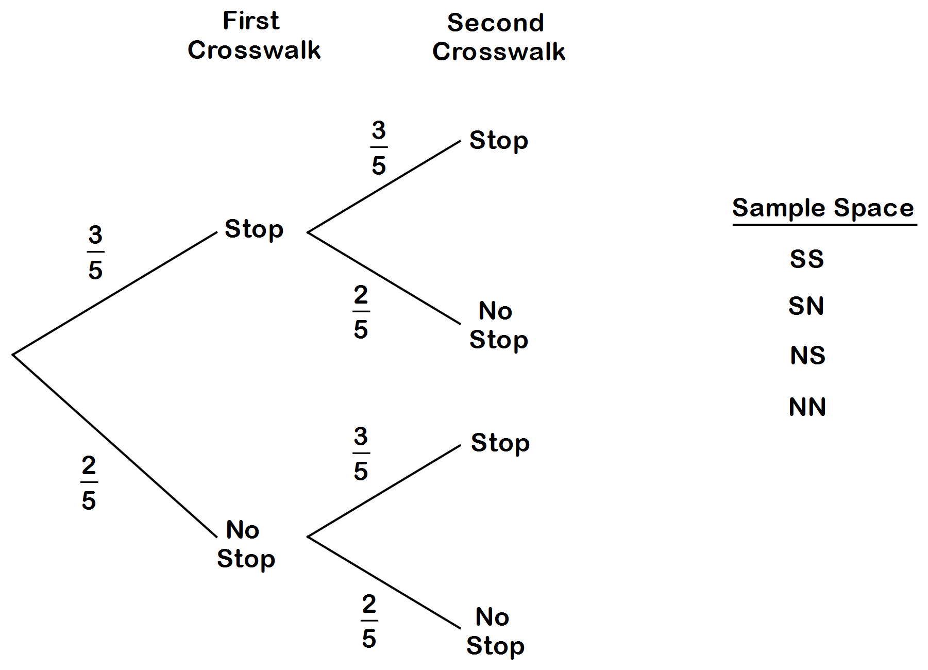

Marking Key/mathematical behaviours | Marks
- correctly drawn and labelled tree diagram  - states the sample space | 1  1

Question 12(b)
Solution
c | 0 | 1 | 2
Pr(C = c) | 0.16 | 0.48 | 0.36

Marking key/mathematical behaviours | Marks
- calculates correct probabilities (if only two correct, allow 1 mark) | 2

Question 12(c)
Solution
n = 5 p = 0.84, $μ=np$
= 5(0.84)
= 4.2
$∴$ The Bernesse family may expect to stop at least once, five times over the five days.

Marking key/mathematical behaviours | Marks
- recognises the binomial distribution and correctly calculates the expected value | 1+1

Question 13(a)
Solution
Pr (train is late 4 times out of 15)
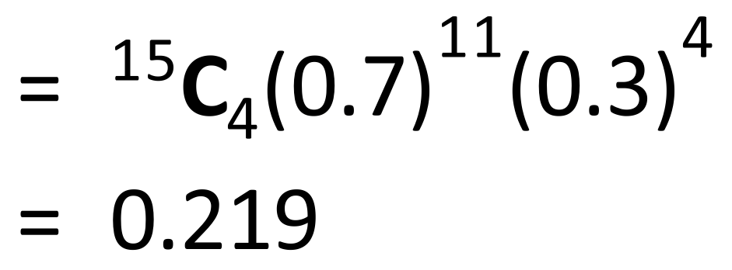
Marking key/mathematical behaviours | Marks
- recognises the binomial distribution and correctly calculates the expected value | 1+1

Question 13(b)
Solution
Pr (train is late 4 times for at least 2 of the next 8 days):
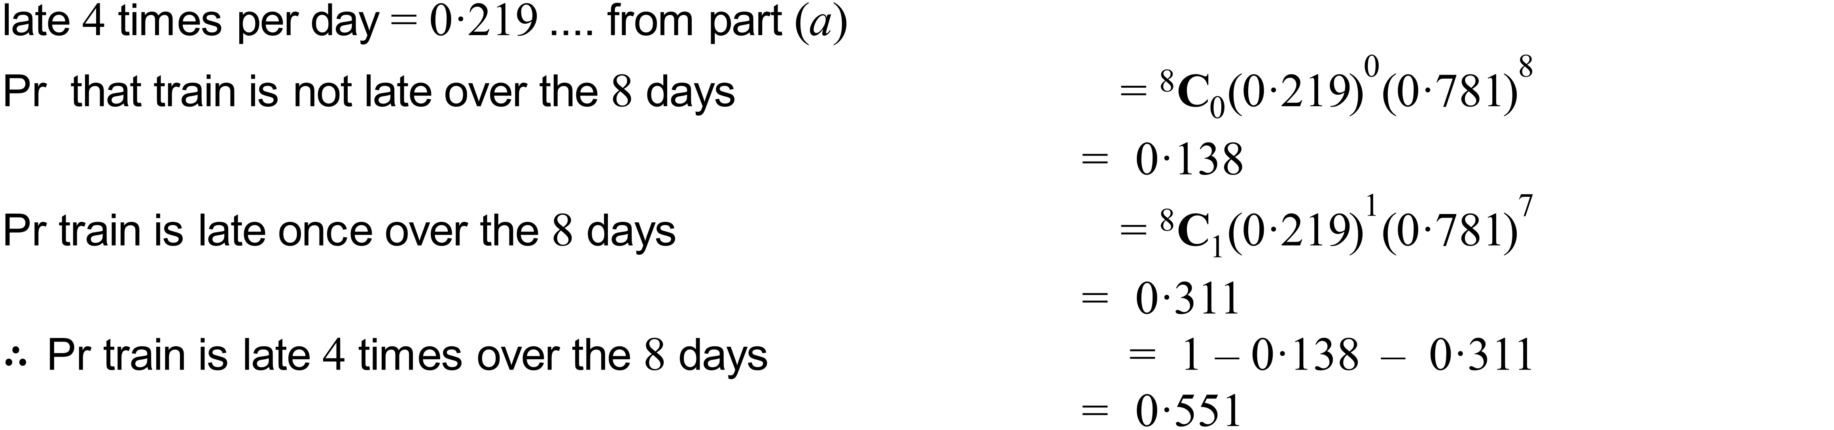

Marking key/mathematical behaviours | Marks
- calculation of probability of train not being late (using result from (a)  - calculates probability for train late once  - subtracts the two probabilities from one to achieve end result | 1  1  1

Question 13(c)
Solution
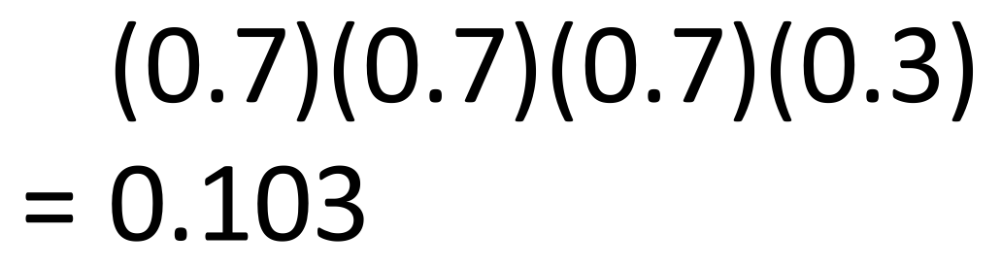
Marking key/mathematical behaviours | Marks
- recognizes ordered probability and uses appropriate calculation | 1

Question 14(a)
Solution
Since 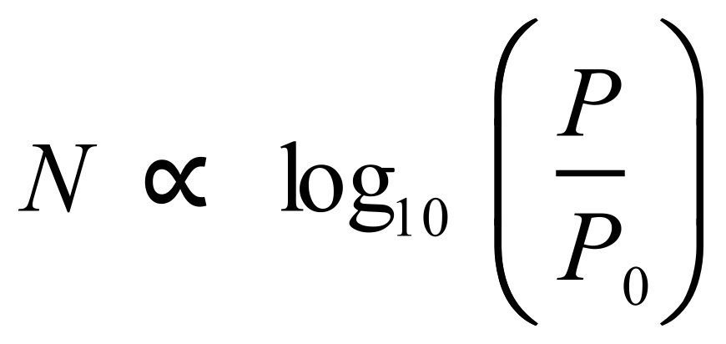 , where  is the noise level in decibels and  is the power and 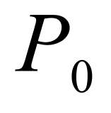 is a reference power level, and since  increases by 10 if the power increases by a factor of 10, 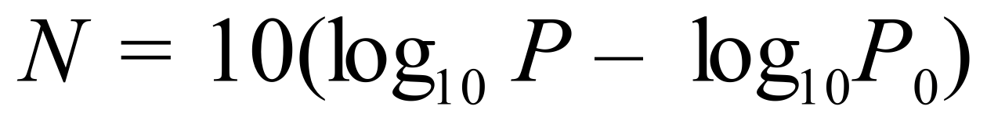, (#)
So if  increases by a factor of 40,  increases by 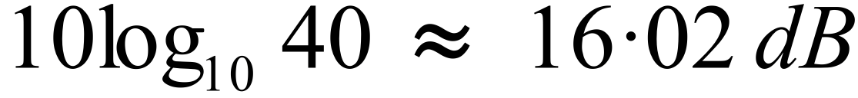
Marking key/mathematical behaviours | Marks
- obtains equation (#) or equivalent  - obtains correct answer | 1  1

Question 14(b)(i)
Solution
Since 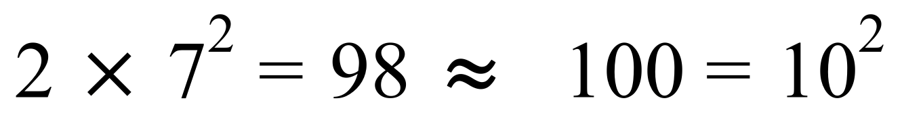
it follows that 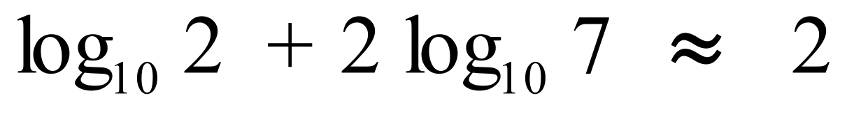 (#)
i.e. 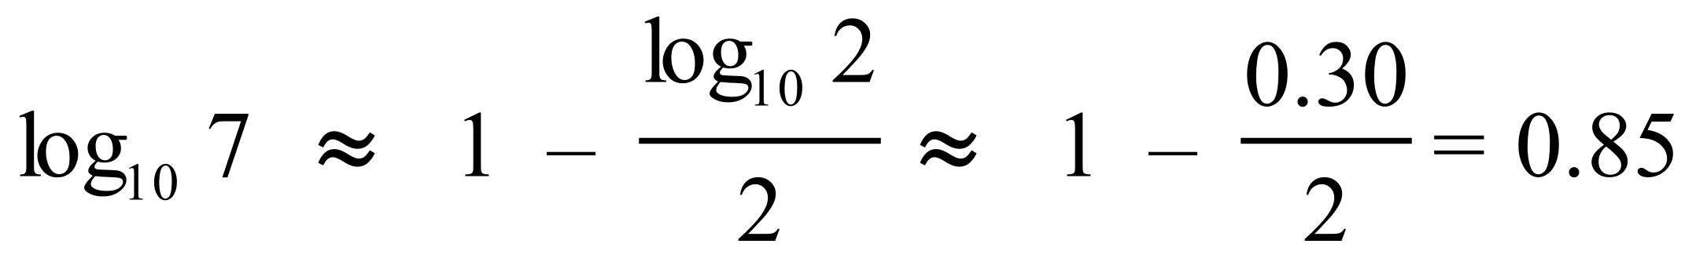
Marking key/mathematical behaviours | Marks
- obtains approximation (#)  - obtains correct answer | 1  1

Question 14(b)(ii)
Solution
Since 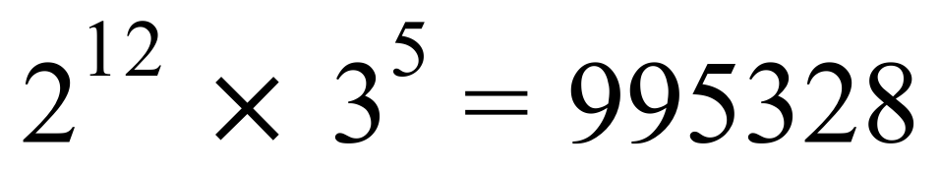
and 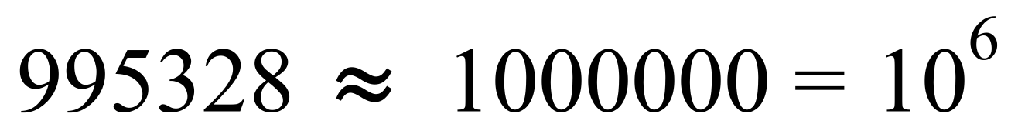
it follows that 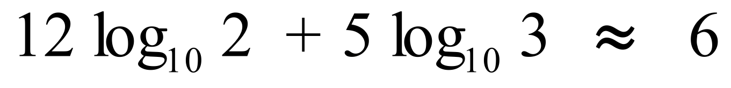 (#)
and so 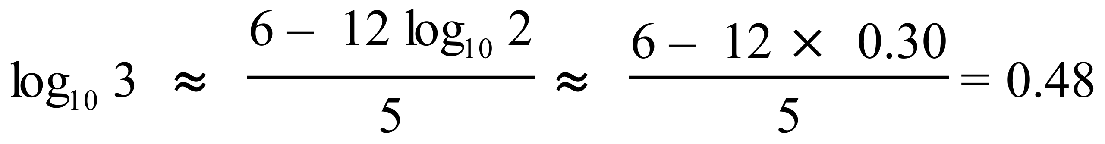
Marking key/mathematical behaviours | Marks
- evaluates 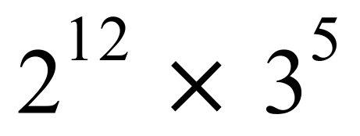 correctly  - obtains approximation (#)  - obtains correct answer | 1  1  1

Question 15(a)
Solution
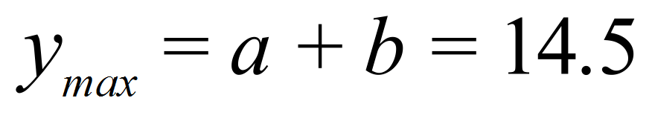 and 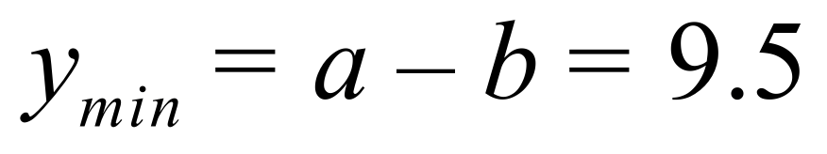 (#)
and so 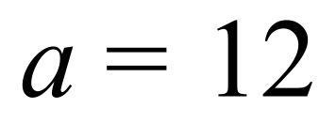 and 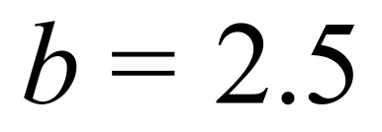
Since the period is 1 year, i.e. 365 days, 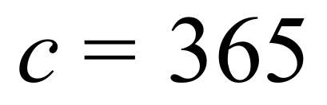
Marking key/mathematical behaviours | Marks
- obtains equations (#)  - solves for  and  correctly  - obtains correct value for 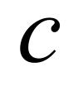 | 1  1  1

Question 15(b)
Solution
When 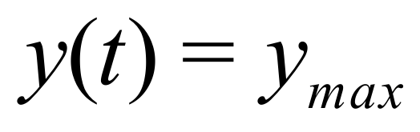 we have 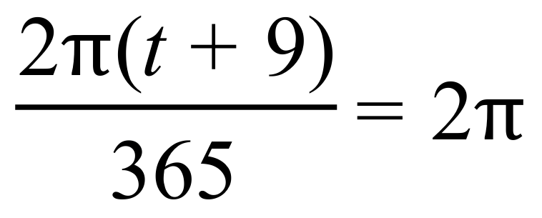 (#)
i.e. 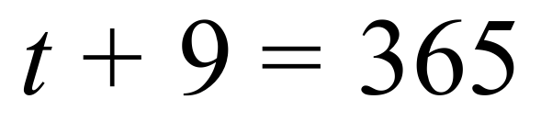 i.e. 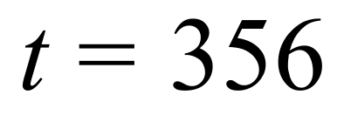
So the 356th day, (December 22nd) will be the longest day.
Marking key/mathematical behaviours | Marks
- obtains equation (#)  - obtains correct answer | 1  1

Question 15(c)
Solution
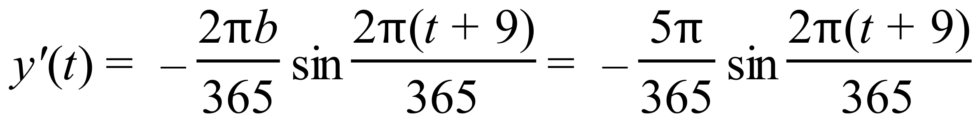
So 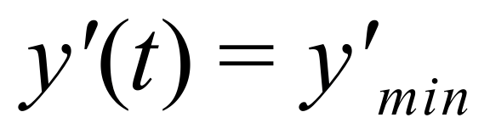 when 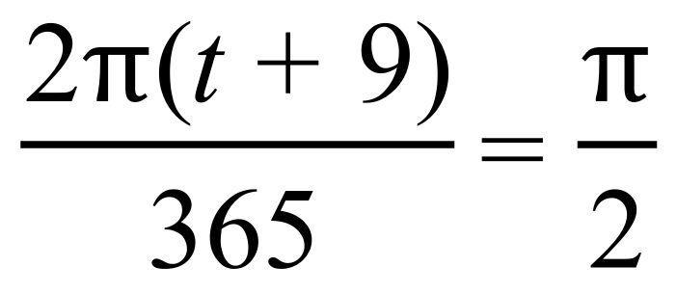 (#)
i.e. when 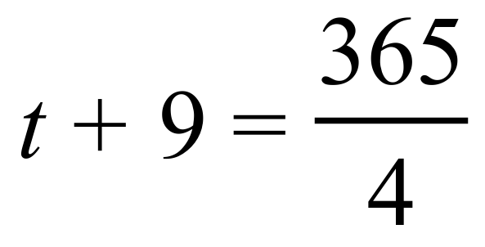 i.e. 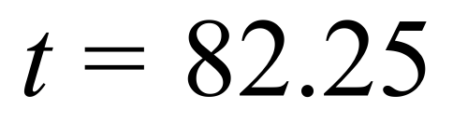
So the number of daylight hours will be decreasing fastest on the 82nd day, i.e. on March 23rd.
Marking key/mathematical behaviours | Marks
- differentiates correctly  - obtains equation (#)  - obtains correct answer | 1  1  1

Question 15(d)
Solution
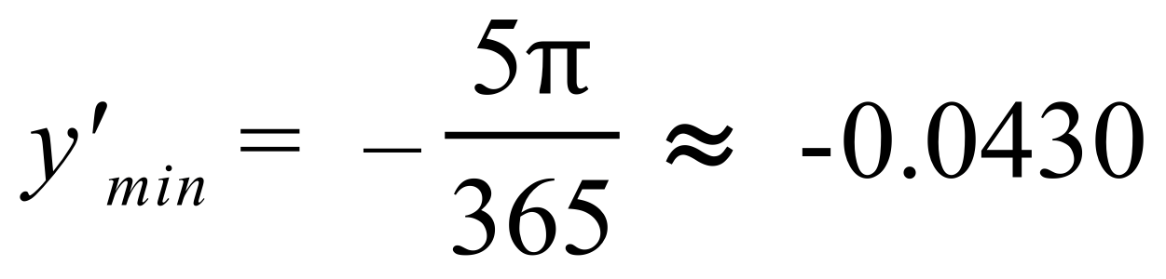
By the increments formula 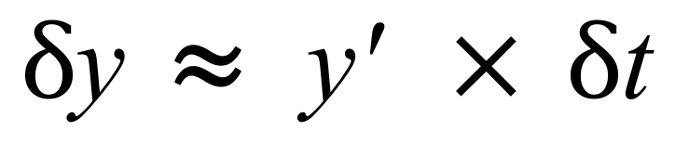 and so if 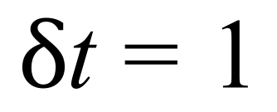 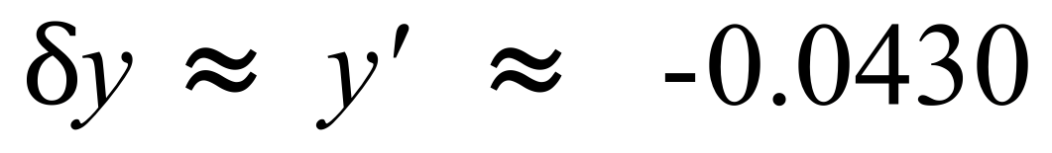
So the largest difference in the number of daylight hours in successive days is 0.043 hours, i.e. 2.6 minutes.
Marking key/mathematical behaviours | Marks
- correctly calculates 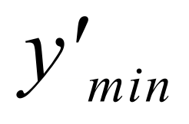  - uses increments formula correctly | 1  1

Question 16(a)
Solution
(i) 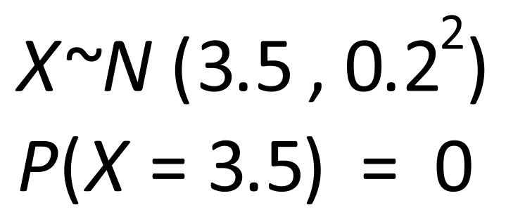

(ii) 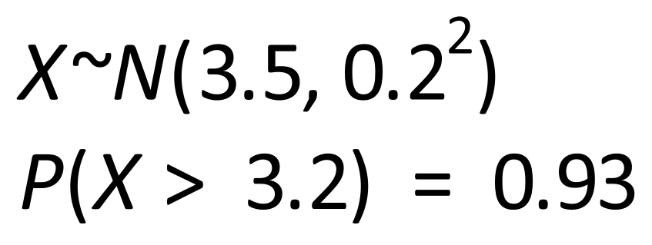

(iii)
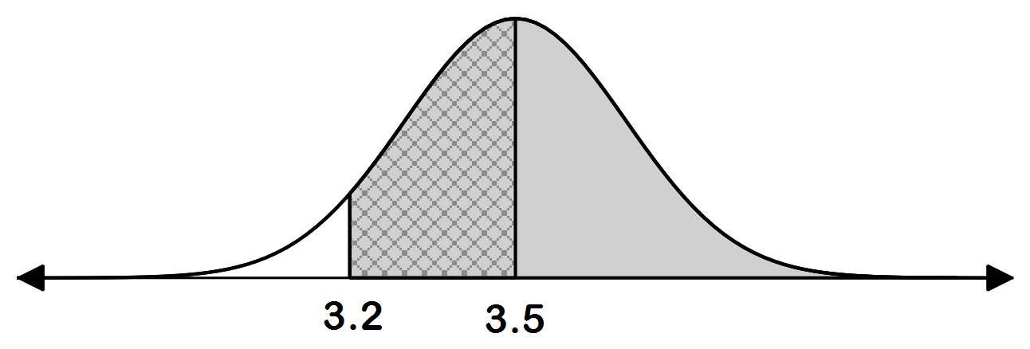

Marking key/mathematical behaviours | Marks
- recognises exact probabilities are equal to zero  - calculates correct probability  - applies the appropriate formula and associated probabilities leading to the correct answer and correct diagram | 1  1  1+1+1

Question 16(b)
Solution
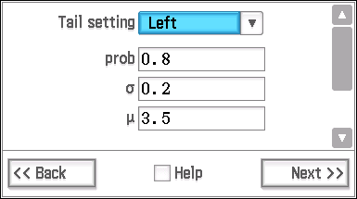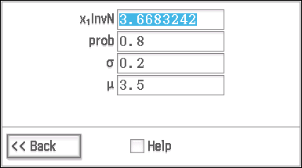
Marking key/mathematical behaviours | Marks
- states probability condition involving  - calculates the correct value for | 1  1

Question 16(c)
Solution
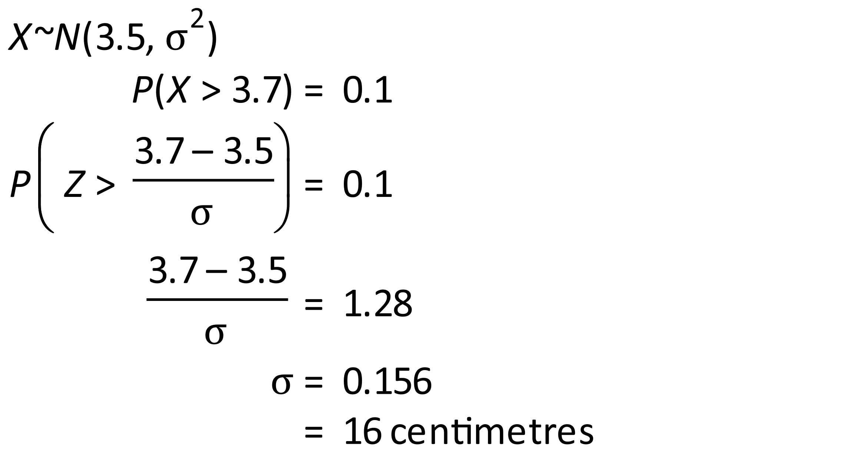
Marking key/mathematical behaviours | Marks
- uses the correct formula and substitutes values  - calculation the standard score  - states the correct answer | 1  1  1

Question 17(a)
Solution
$$v= \int{3\sin\left(2t\right)dt}$$

$= - \frac{3}{2}$ cos(2t) + c

$$t=0 → - \frac{3}{2}+c = 4$$

c = 5.5

$∴ v = - \frac{3}{2}\cos\left(2t\right)+ 5.5$

Marking key/mathematical behaviours | Marks
- correctly integrates to find equation for v involving c  - correctly evaluates c  - writes an expression for v | 1  1  1

Question 17(b)
Solution
$$x= \int{\left[- \frac{3}{2}\cos\left(2t\right)+5.5\right] dt}$$

$= - \frac{3}{4}\sin\left(2t\right)+5.5t+c$

When $t=0 → c = 2$ or - 2

When $t=2 → x= - \frac{3}{4}\sin\left(4\right)+5.5\left(2\right)∓$2

= 13.57 m or 9.57 m

Marking key/mathematical behaviours | Marks
- determines correct integral of function plus c  - calculates a value for c  - calculates x accurately when t = 2 and includes both possible values | 1  1  1+1

Question 18(a)
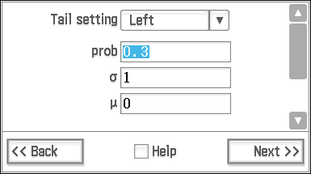
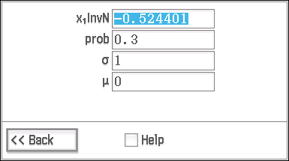
Solution
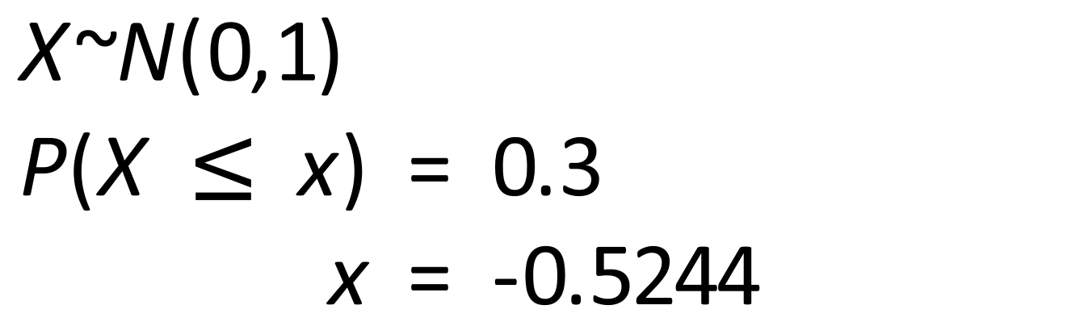

Marking key/mathematical behaviours | Marks
- identifies the parameters of the standard normal and states the problem in terms of probability  - states the correct result | 1  1

Question 18(b)
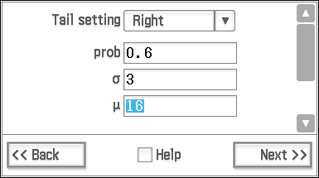
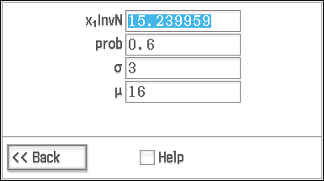
Solution
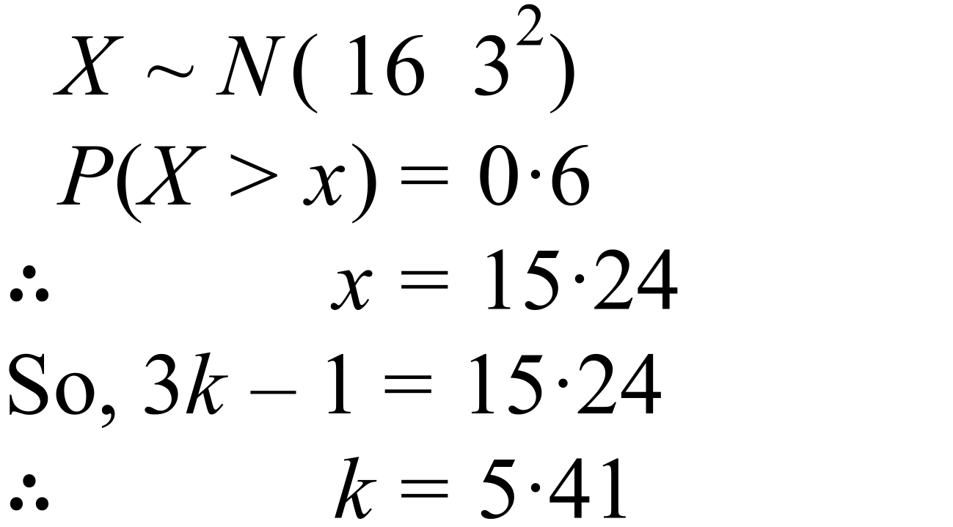

Marking key/mathematical behaviours | Marks
- applies the normal distribution to determine x  - states the correct result for k | 1  1

Question 18(c)
Solution
The x-value of 6 is 2.4 standard deviations away from the mean.
Marking key/mathematical behaviours | Marks
- provided an acceptable explanation | 1

Question 18(d)
Solution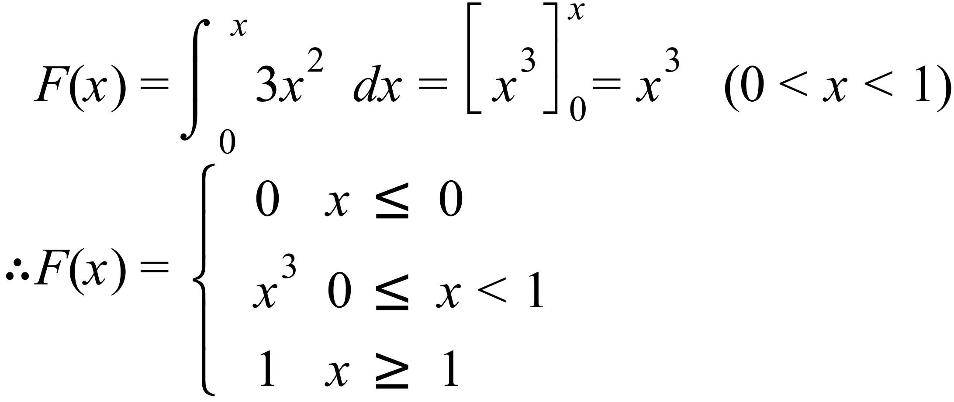

Marking key/mathematical behaviours | Marks
- evaluates the correct integral  - defines F(x)  - states the three domains correctly for F(x) | 1  1  1

Question 19
Solution
Check sample size is large enough for normal approximation np >10 and
n(1 – p) > 10.

In this case, 1000 x 0.48 = 480 > 10
1000 x 0.52 = 520 > 10
Therefore, normal approximation can be applied.

$CI = 0.48±1.96 \sqrt{\frac{0.48 x 0.52}{1000}}$

= $0.48 ±0.03097$

= (0.45, 0.51)

(0.45, 0.51) is a 95% Confidence Interval for the true proportion of students excited by the upcoming concert.
Marking key/mathematical behaviours | Marks
- Checks the sample size for normal approximation  - Sets up CI and evaluates correctly  - correctly interprets result | 1+1  1+1  1

Question 20(a)
Solution
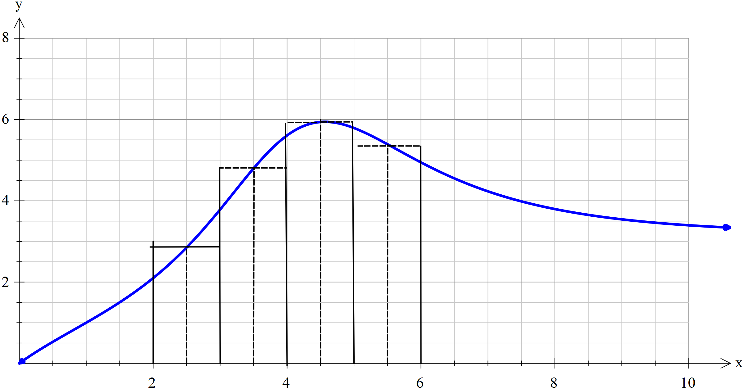

The area is approximately 20 square units.
- The area represents the distance travelled by the projectile between
Marking key/mathematical behaviours | Marks
- estimates the function at the values suggested (allow )  - applies the summation correctly  - states the required area  - correctly interprets the meaning of the area as the distance travelled | 2  1  1  1

Question 20(b)
Solution
The area of the triangle formed by and the (between )
= 1 square unit.
Hence,
- region A =

Marking key/mathematical behaviours | Marks
- Calculates the area of the triangle  - Calculates the area of region A  - Defines region B in terms of integrals of  - Re-arranges the integrals using the integral properties so as to be able to use the information given  - Shows the required result. | 1  1  1  2  1

Question 21(a)
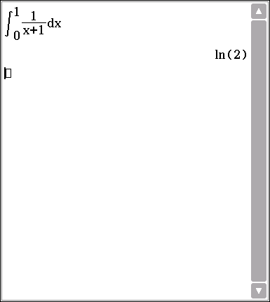
Solution
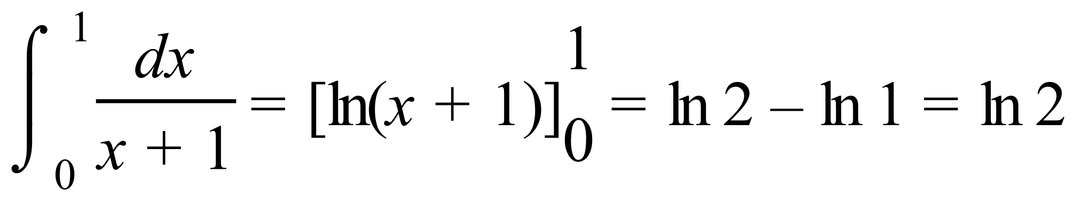
Marking key/mathematical behaviours | Marks
- obtains 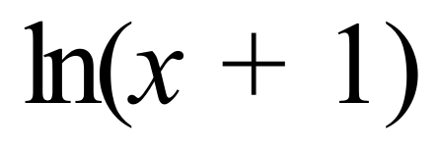 as the antiderivative  - evaluates at limits correctly | 1  1

Question 21(b)
Solution
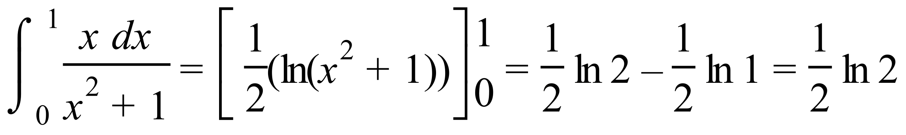
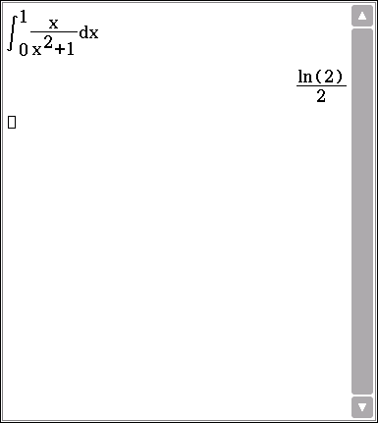
Marking key/mathematical behaviours | Marks
- obtains 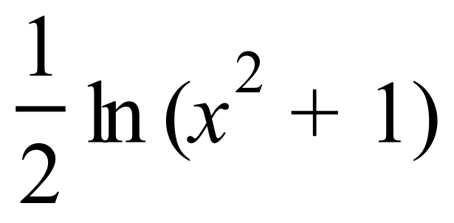 as the antiderivative  - evaluates at limits correctly | 1  1

Question 21(c)(i)
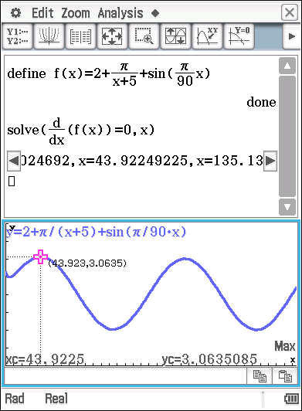
Solution
Rate of heat loss is a maximum at
Maximum rate of heat loss is ~ 3 kilojoules per day.

Marking key/mathematical behaviours | Marks
- states correct values of  - states the maximum rate of heat loss | 1+1  1

Question 21(c)(ii)
Solution:
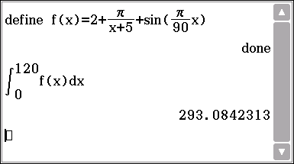

The heat loss is ~293 kilojoules.

Marking key/mathematical behaviours | Marks
- indicates that the heat loss in the integral from 0 to 120 of  - states the correct result  - states the correct units | 1  1  1

Question 21(c)(iii)
Solution
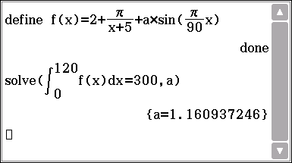

Marking key/mathematical behaviours | Marks
- indicates solving the integral of from 0 to 120 of = 300  - states the correct result | 1  1

Question 22(a)
Solution
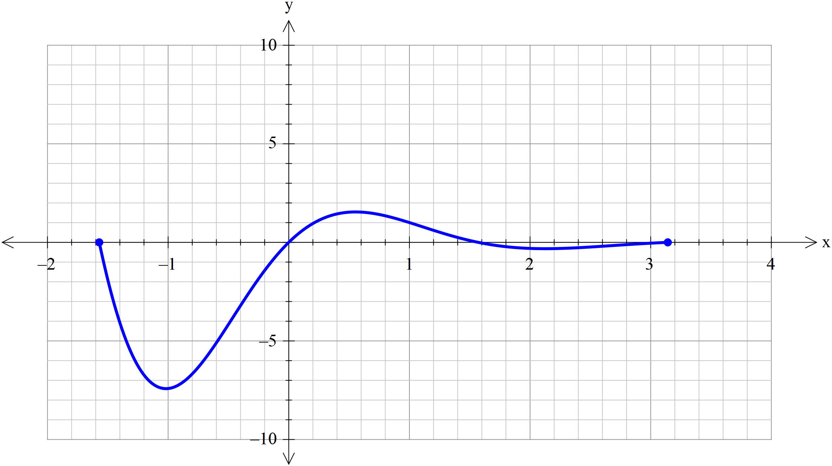
Marking key/mathematical behaviours | Marks
- Clearly shows the correct intercepts  - Minimum and maximum points are reasonably accurate  - Graph is appropriately smooth | 1  1  1

Question 22(b)
Solution
Using the CAS calculator to solve for a:
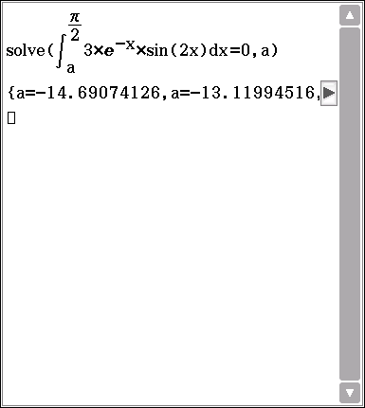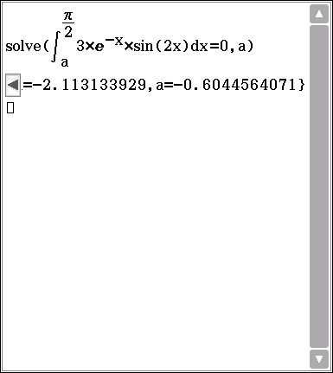
From the graph in part (a) it is obvious that so, need to select
Marking key/mathematical behaviours | Marks
- Solves correctly (if provides additional values for a – subtract one mark) | 2

© MAWA, 2017
This examination is Copyright but may be freely used within the school that purchases this licence.
- The items that are contained in this examination are to be used solely in the school for which they are purchased.
- They are not to be shared in any manner with a school which has not purchased their own licence.
- The items and the solutions/marking keys are to be kept confidentially and not copied or made available to anyone who is not a teacher at the school. Teachers may give feedback to students in the form of showing them how the work is marked but students are not to retain a copy of the paper or the marking guide until the agreed release date stipulated in the purchasing agreement/licence.
Published by The Mathematical Association of WA
12 Cobbler Place, MIRRABOOKA 6061

